Description of the Student Management System

Full name | Student ID | Role
Hà Văn Bảo | 051203014096 | Leader + Requirement specifications + Design
Lê Hoàng Minh Khang | 082206004707 | Draw DFD
Phạm Nguyễn Gia Bảo | 079206004263 | Draw Use Case Diagrams
Lê Thế Huy | 083206000728 | Draw Class Diagrams
Nguyễn Nhật Toàn | 079206045477 | Requirement specifications + Design
Member list

Document Change Record:

Date | Version | Describe | Author
7/4/2026 | 1.0 | Create documentation describing functional and non-functional requirements. Draw DFD diagrams, use case diagrams, and class diagrams.  Design the database, format tables, primary keys, and foreign keys.

Student Management System Description
PortalSV aims to develop a student management system with the following core features:
- View Personal Information and Courses
- Access Workflow:
- The system requires users to log in if they have not already authenticated. It will automatically perform role-based differentiation to categorize users into three groups: Students, Teachers, or School Administration.
- For Teachers: Includes personal profile (Teacher ID, Full Name, Email, Phone Number, Department). Teachers can manage multiple courses and view the student rosters for their assigned classes.
- For Students: Includes Student ID card details (Student ID, Full Name, Date of Birth, Academic Year, Major), personal schedules, course registration, and a list of enrolled courses.
- For School Administration: Provides access to classroom data, faculty directories, comprehensive student lists, and other administrative information.
- Course/Teaching Schedule Registration:
- Teachers: Allowed to register for suitable teaching schedules, must meet the minimum number of required teaching schedules per week and the minimum number of classes taught per semester.
- Students: Allowed to register for optional courses including uncompleted and failed courses, with a total credit requirement of no more than 22 credits and no less than 15 credits per semester.
- Courses:
- Students can only register for new courses at the beginning of each semester and register for courses they have failed if the school administration opens those courses.
- Teachers are not allowed to register for courses; they are only assigned to teach by the school administration.
- The school administration may open course registration for students and assign teachers to subjects that have reached full student enrollment.
- Update Information:
- Students and teachers can update necessary personal information.
- Personal information includes: full name, date of birth, phone number, username, and password.
- In case of a forgotten password, email and phone number verification will be performed, and a new password will be sent to your email.
- System Administration: Admin (school management) has the following functions:
- Student Management
- Teacher Management
- Course Management
- User Interface Design
- Main menu
=== STUDENT MANAGEMENT SYSTEM =====
1.1. Login
1.2. Forgot Password
1.3. Exit
- Student Menu (Level 3)
2.1. View profile - id
2.2. View score
2.3. View Courses
2.4. Enroll Course
2.5. View Enrollment
2.6. Cancel Enrollment
2.7. Logout
- Teacher Menu (Level 2)
3.1. View Profile
3.2. View Course
3.3. View Student List
3.4. Enter Score

- Admin Menu (Level 1)
4.1. Manage Student
4.2. Manage Teacher
4.3. Manage Course
4.4. Manage Enrollment
- Use case diagrams
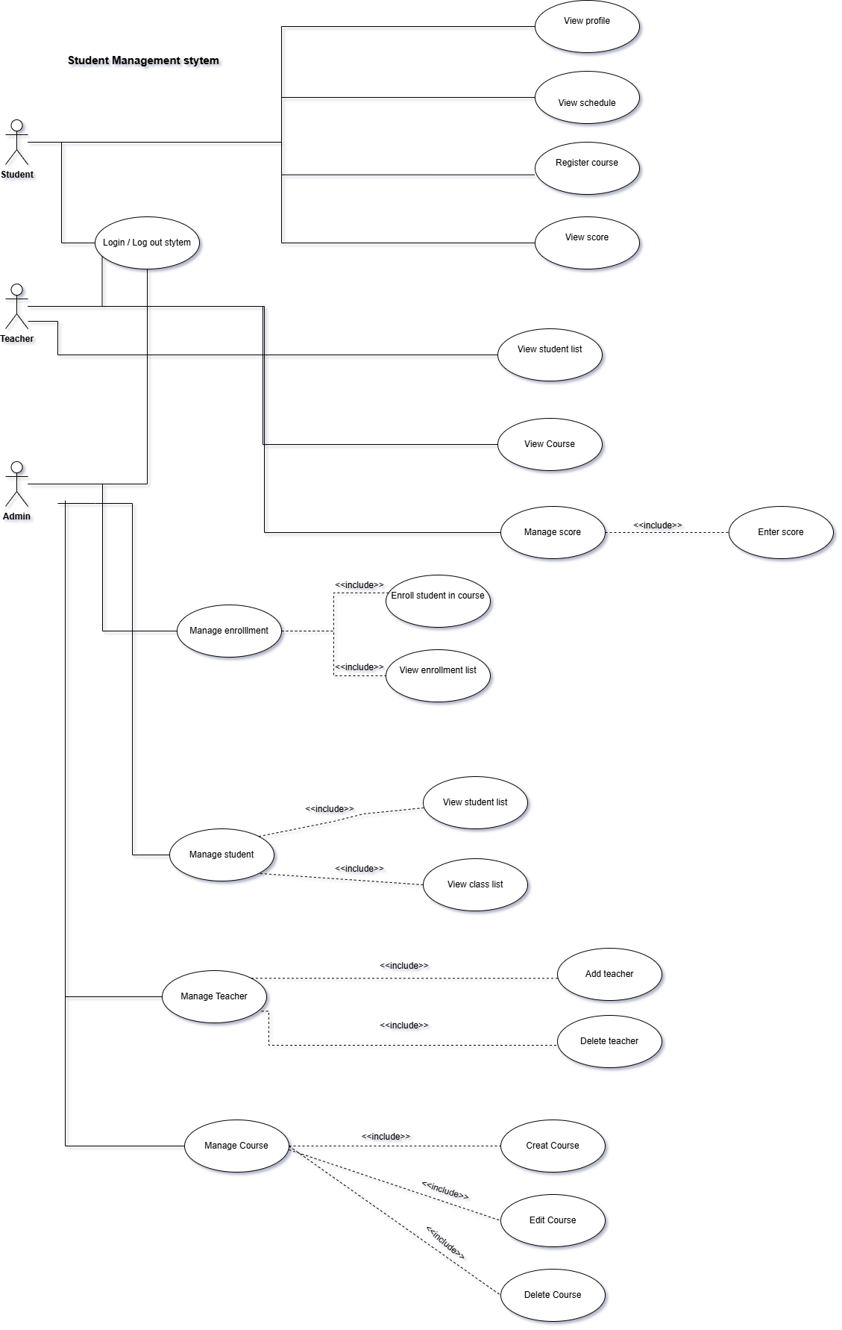
- Class diagrams
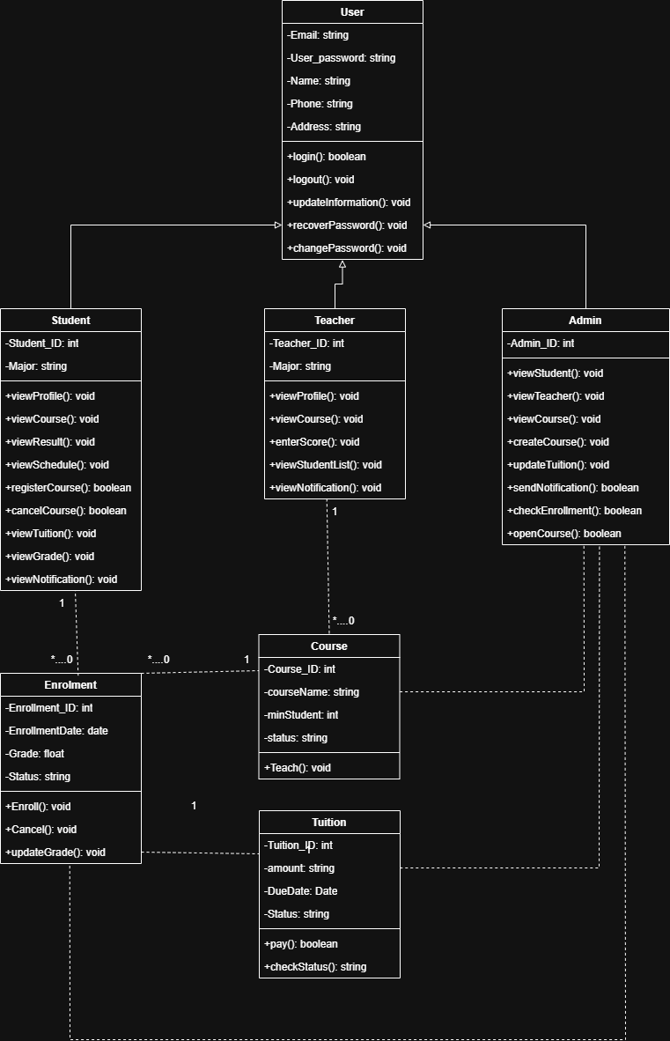
- DFD diagrams
- DFD Level 0
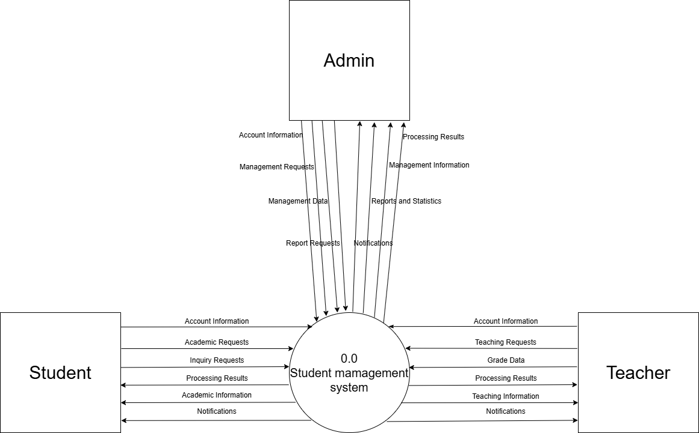
- DFD Level 1
2.1 1.0 Account Management
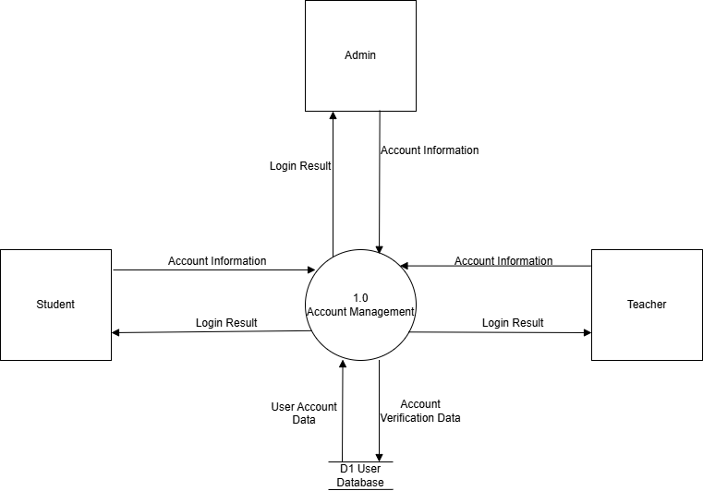
2.2 2.0 Personal Information Management
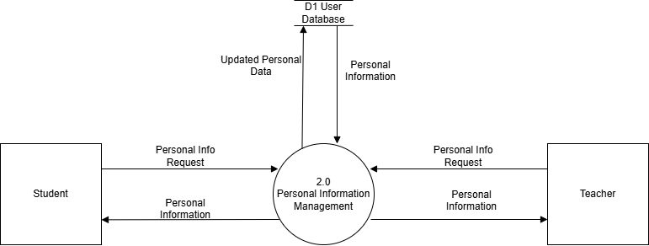
2.3 3.0 Course Registration Management
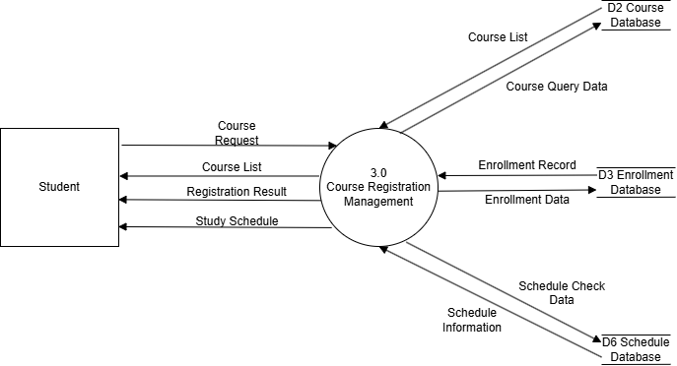
2.4 4.0 Grade Management
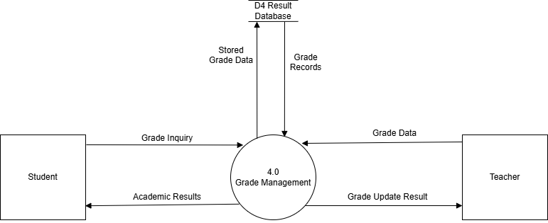
2.5 5.0 Tuition Management
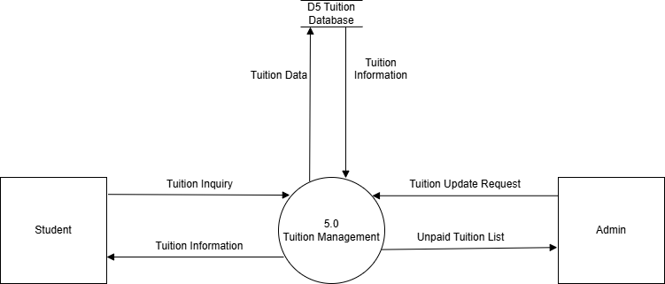
2.6 6.0 Report and Notification Management
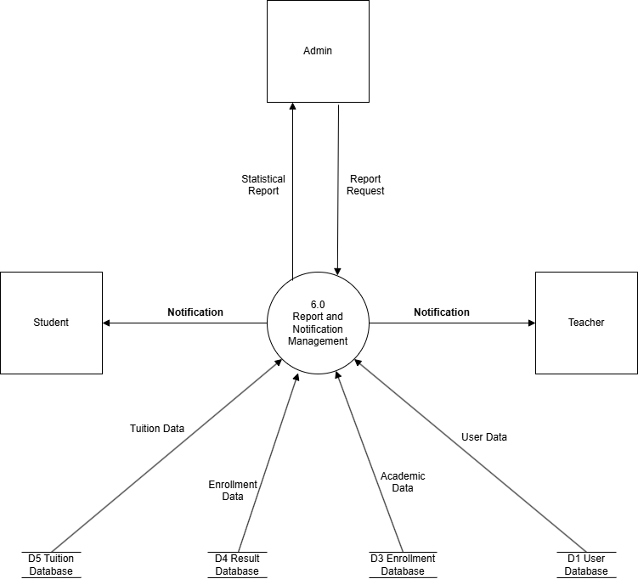
- DFD Level 2
3.1 1.0 Account Management
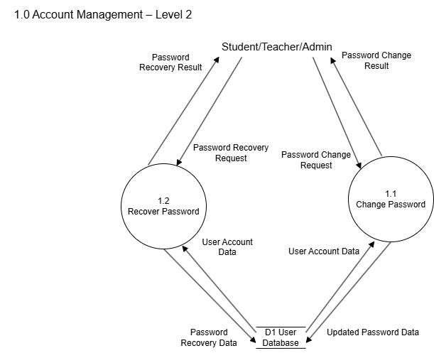
3.2 2.0 Personal Information Management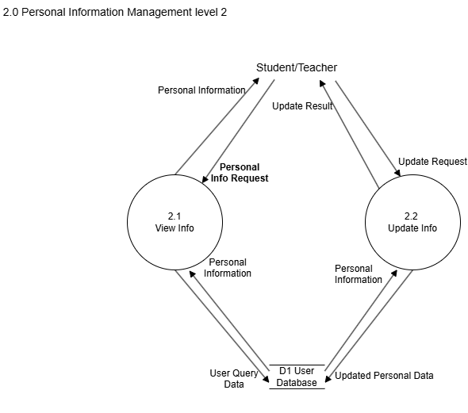
3.3 3.0 Course Registration Management
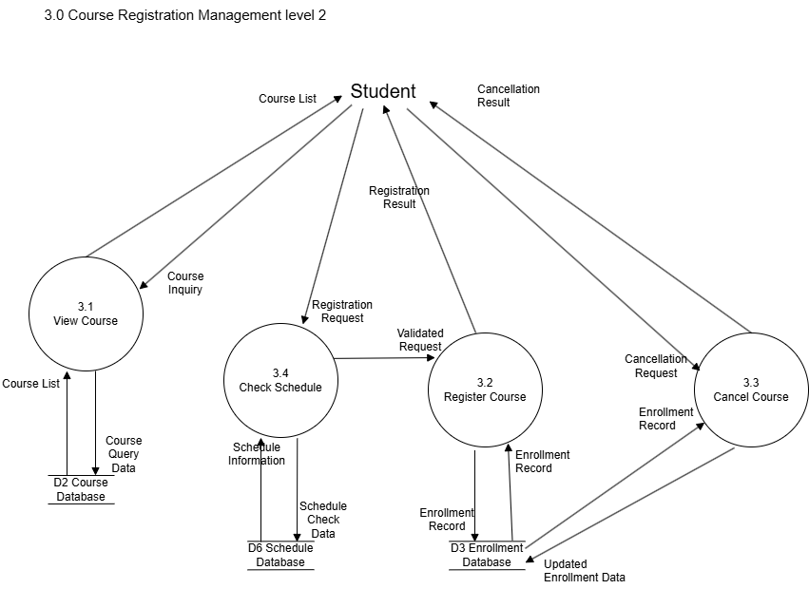
3.4 4.0 Grade Management
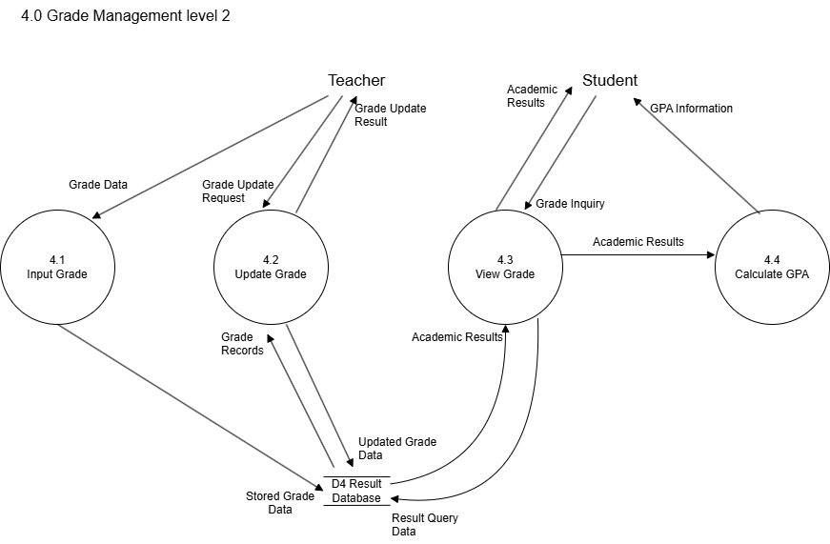
3.5 5.0 Tuition Management
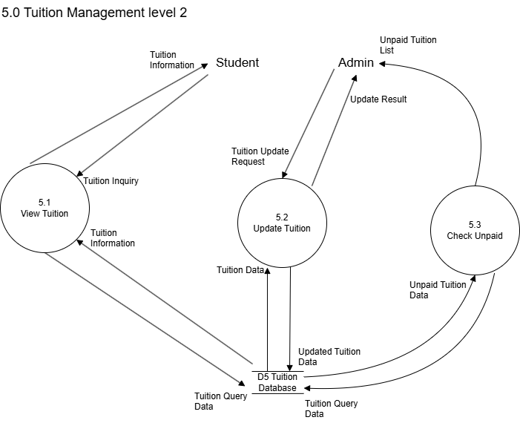
3.6 6.0 Report and Notification Management
